<http://www.cburch.com/proj/autosim/download.html>

1. Design DFA to accept bcaaaaaaaaaaaaaa, bc, and c

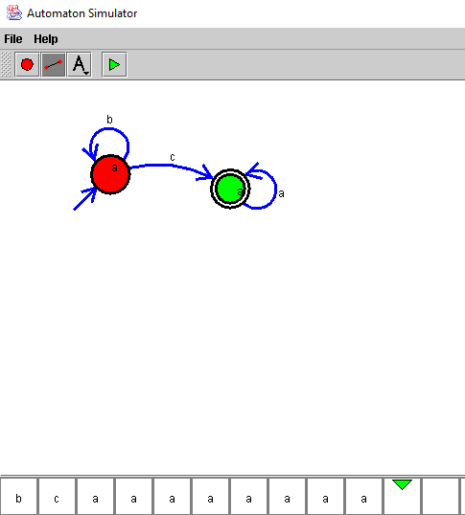

2.Design NFA to accept aaaaaa

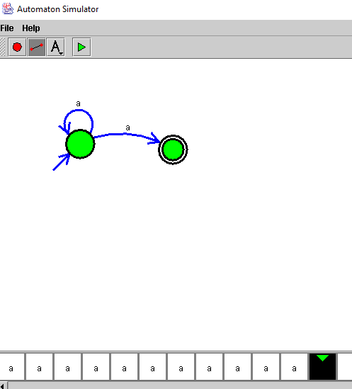

3.Design PDA for the input a^nb^n

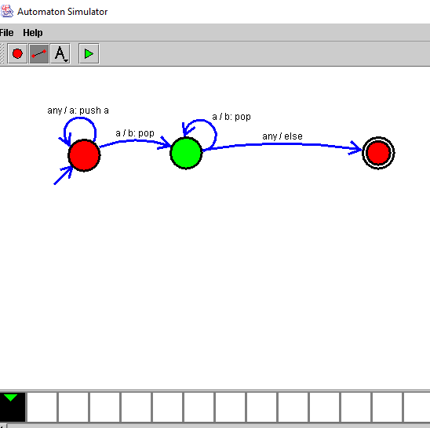

4.Design Tm For input a^nb^n

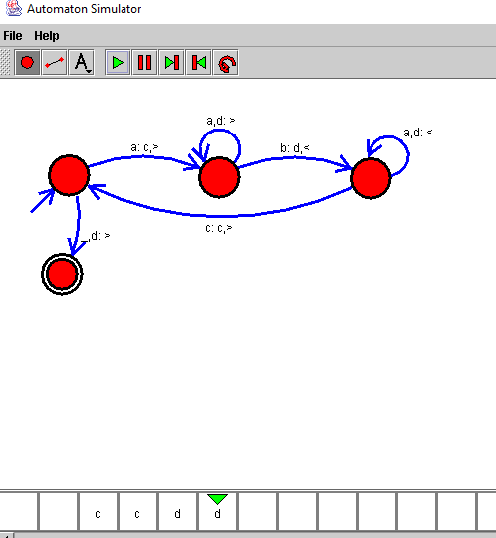

5 .Design PDA for input aabbbbc ( L=a^nb^2n)

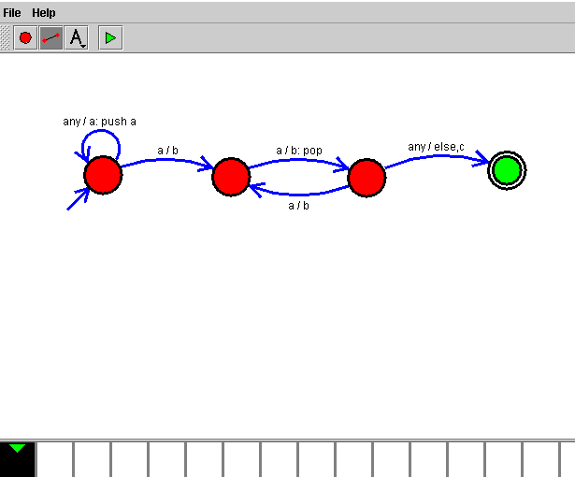

6.TM Simulation for Palindrome W= ababa c

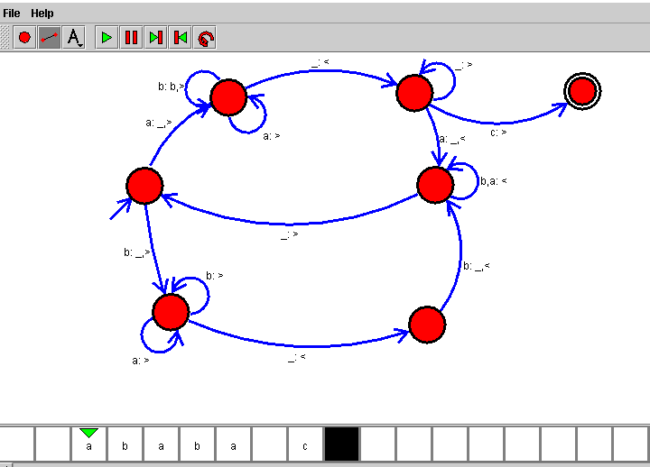

7.Design TM to perform addition of following

W= aa + aaaa

After Addition of a’s = aaaaaa

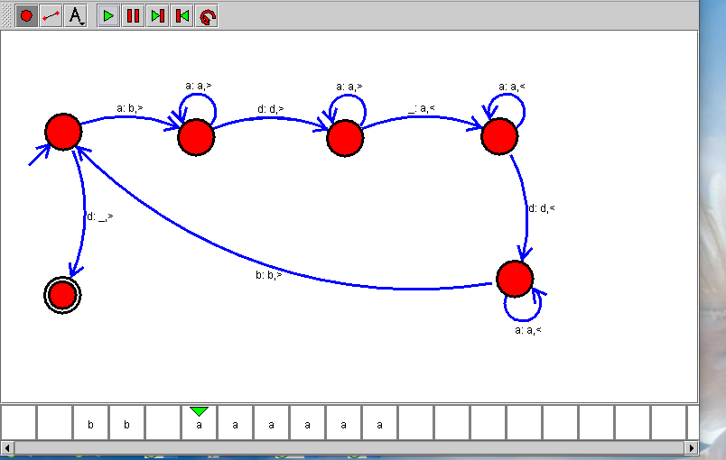

8.Design TM to perform subtraction

W= aaa-aa

The Result of Subtraction is = a

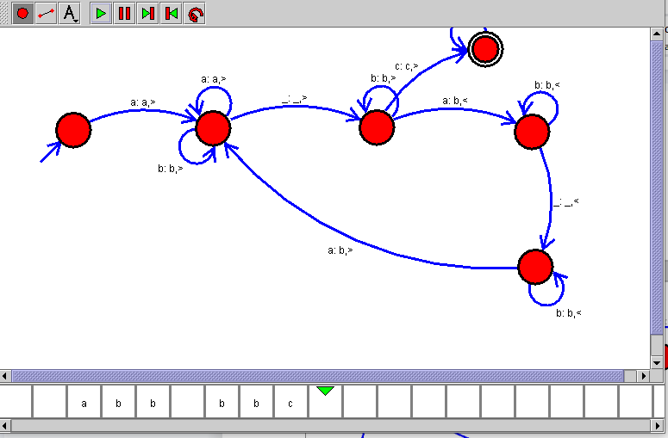

9.Design TM to perofrm string comparison

W = aba aba

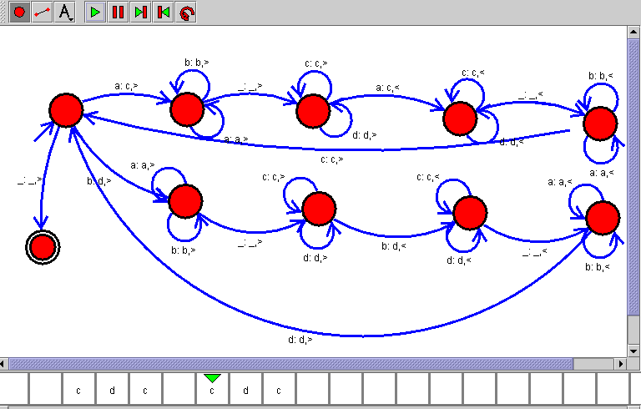

<https://web.stanford.edu/class/archive/cs/cs103/cs103.1156/tools/cfg/>

1. Write CFG to product string which consists of substring ‘aa’

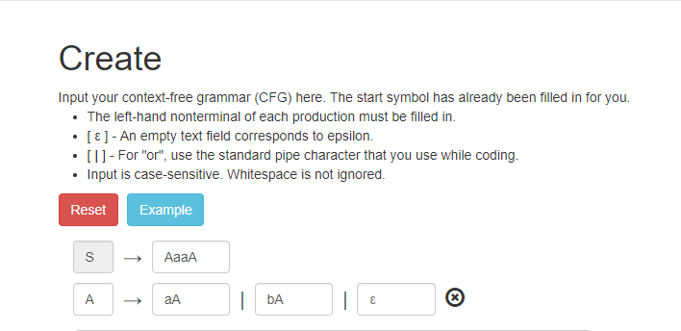

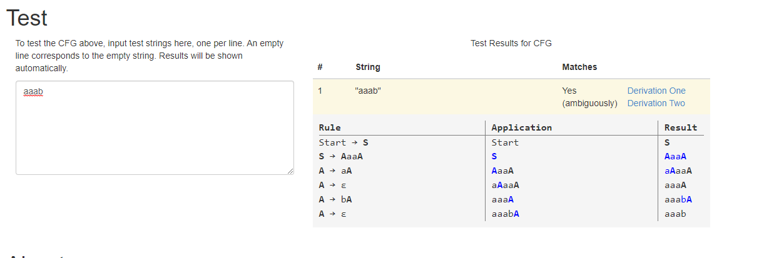

11.Write Context Free Grammar to Generate Palindrome

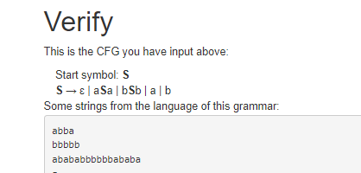

12. 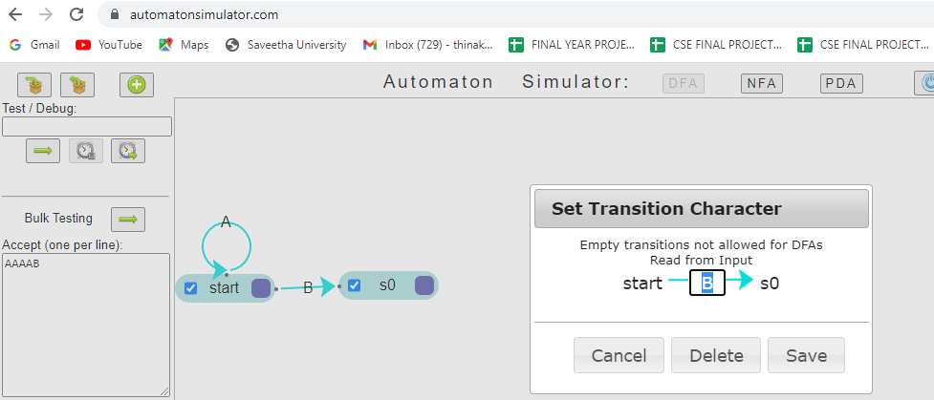

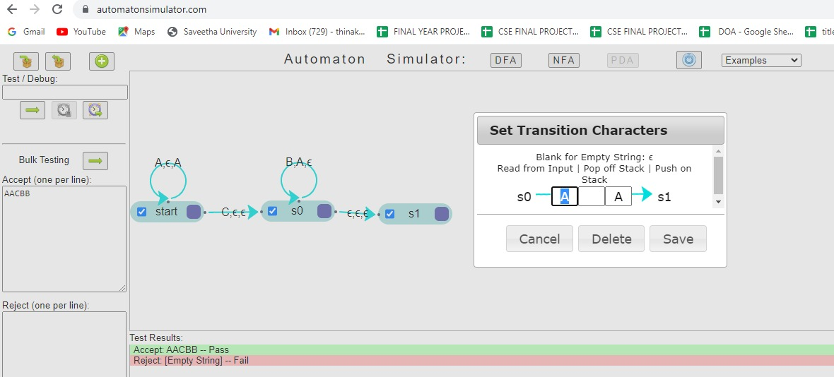

13.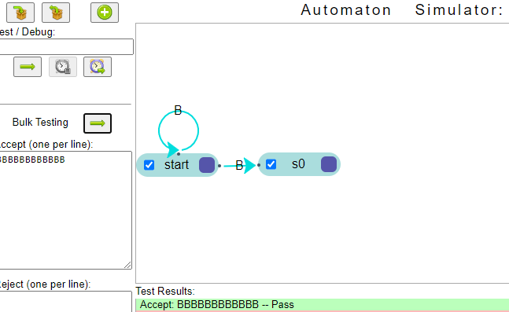

1. Write CFG which will produce string over set = {a,b} that start with ‘a’ and end with ‘b’

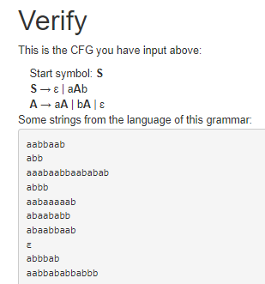

1. Design PDA to accept event number a’s and even number b’s